Experiment-2.2
Student Name: Himanshu UID: 20BCS7944
Branch: BE-CSE Section/Group: 905 A
Subject Name: IOT Lab Subject Code: 20CSP-358

Aim: To measure the temperature and humidity using an DHT-11 sensor.

Objectives:
- Learn how to make connections with Arduino board .
- Learn using DHT-11 with arduino.

Components Required:
Arduino Uno board, DHT-11 Sensor, Jumper wires, Arduino IDE , Buzzer

Circuit Diagram:

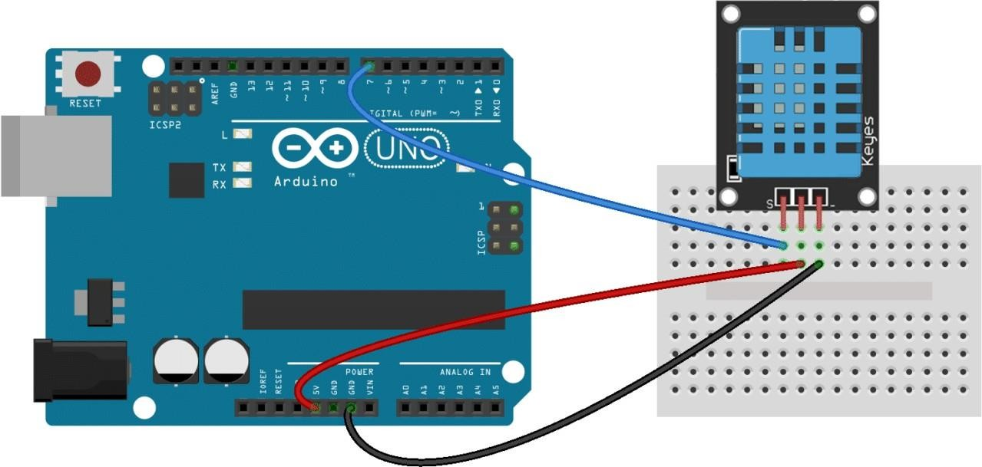
Script & Output:
- (a)Code in Arduino IDE -

#include <dht.h> dht DHT;

#define DHT11_PIN 7

void setup(){ Serial.begin(9600);
}

void loop(){
int chk = DHT.read11(DHT11_PIN); Serial.print("Temperature = "); Serial.println(DHT.temperature); Serial.print("Humidity = "); Serial.println(DHT.humidity); delay(1000);
}
(b) Simulation-

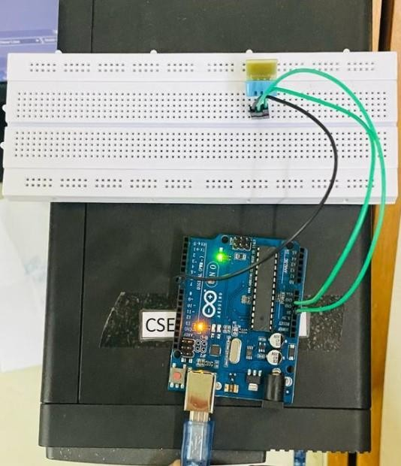

- (a) Code in Arduino IDE (for Analysis) -
#include <dht.h> dht DHT;

#define DHT11_PIN 2
void setup()
{

pinMode(11, OUTPUT); Serial.begin(9600); delay(100);
}

void loop()
{

int sensorValue = DHT.read11(DHT11_PIN); Serial.println("Temp : "); Serial.println(DHT.temperature);
delay(100); if(DHT.temperature>20)
{
digitalWrite(11, HIGH); delay(1000);
}
else
{
digitalWrite(11, LOW); delay(1000);
}
}
(b) Simulation-

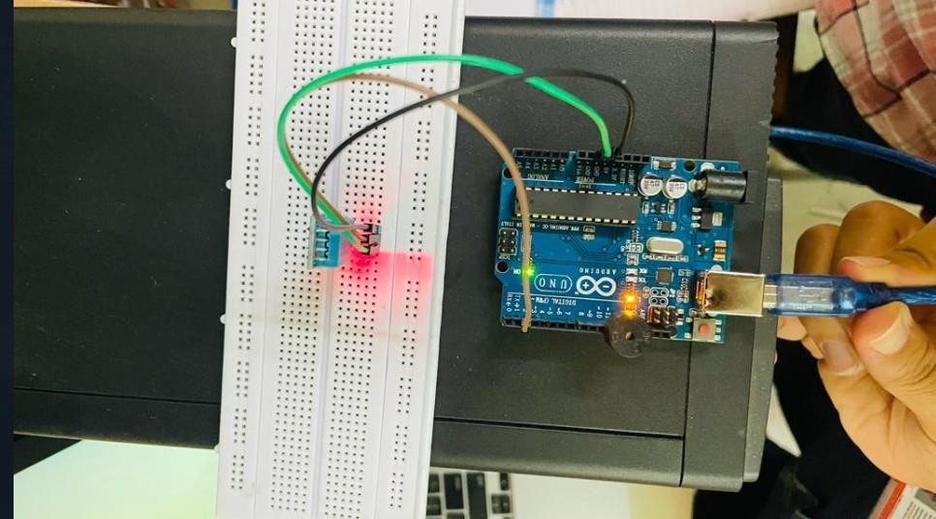

Result:

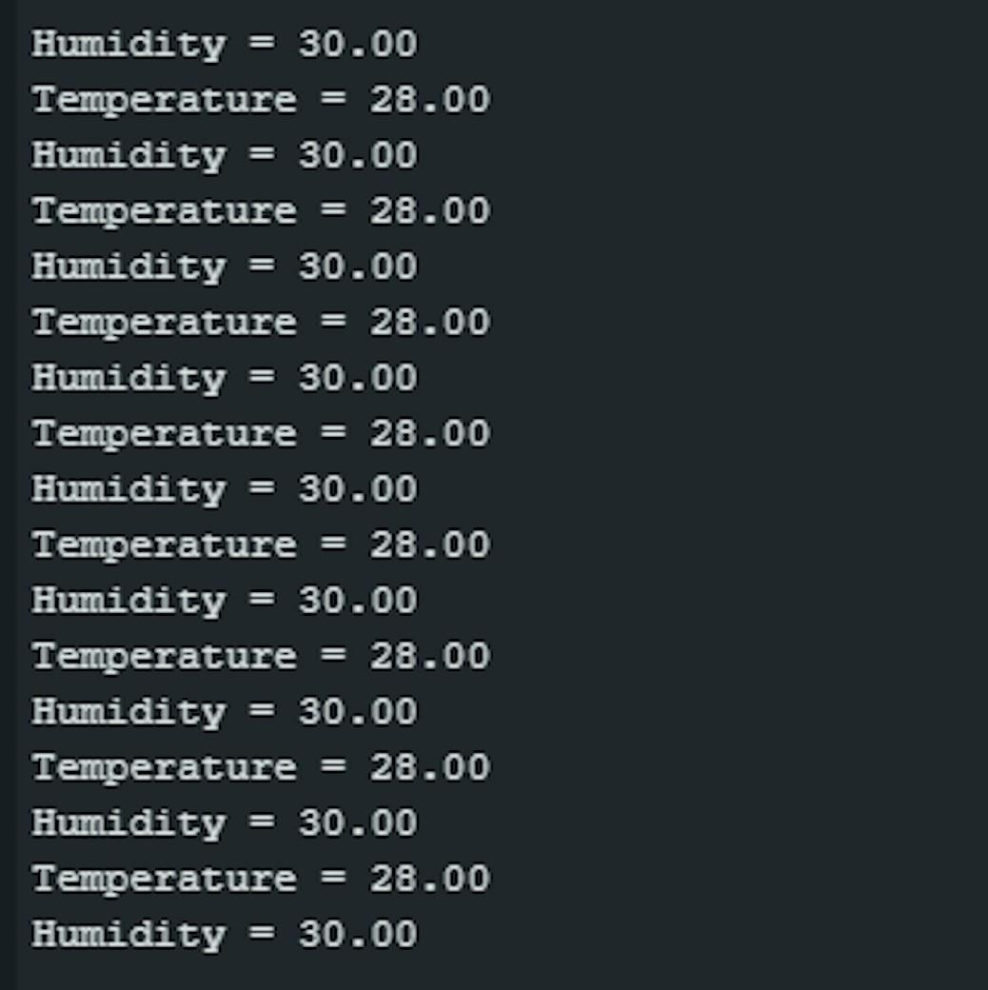
Conclusion:
- We see our sensor respond.
- We learned to use buzzer to perform analysis of our sensor.
- We learned to make the connections with Arduino Board.

